Catalogue of Products of CJSC Scientific and Production Enterprise "AVIASTEK" (designer and producer)
No. | Name of Product | Photo-drawing-  draft
1. | Control unit for control and measuring machines and cloth inspection machines - (type МКМ-20…) - ЛЕН-641 (-А, -Б, -В), including a precise, digital, reversible counter of cloth running metres (accuracy of measurement = +5 mm for any length of cloth taking into account its tightness) | 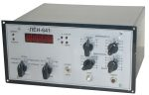
2. | Speed advance unit БОС-641 – cloth metre, speed and advance counter (draft - shrinkage) for drying, stabilizing, dyeing and other textile and special purpose machines/optimization and control of tension, run of cloth/ | 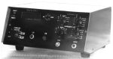
3. | Speed advance unit БОС-642 – multifunctional cloth metre, speed and advance counter (warp draft - shrinkage) for sizing machines (type ШБЛ-3М…) with marking devices / optimization and control of tension, warp passage/ | 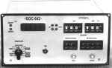
4. | Pulse photoelectric sensors (photo sensors) – operate together with ЛЕН.., БОС…; provide discreteness/accuracy of cloth measurement = 10.5 mm respectively, for cloth of any length):  - ФД-641 Z = 36 (impulses per revolution), reversible | 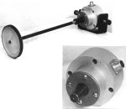
5. | - ФД-641А Z = 72; only for БОС-642, non-reversible
6. | Temperature controller ТР-641Б together with a remote heat-sensing device measures and adjusts temperature at the set level, executed on basis of the PIC controller: t range = 0 – +250 ^{о}С; accuracy to 1%; load current to 16А); power supply voltage – power circuit ~220V, 50/60Hz | 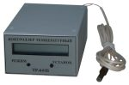  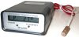
7. | - ТР-641В – same functions and accessories but universal power supply voltage: ~220V from the adapter and/or self-contained power supply of +5V (installed storage batteries charged from the adapter)
8. | Metal worker’s devices (determine types of non-ferrous and ferrous metals, place and degree of thermal treatment by comparison of thermal electromotive force: express control, digital, compact):  - ПМ-641 (voltage/ power supply - power circuit ~220V, 50/60Hz ); | 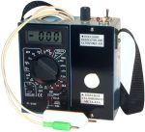
9. | - ПМ-642 (universal power supply voltage – power circuit ~220V, 50/60Hz with the adapter and/or self-contained power supply of -12V – installed storage batteries charged from the adapter, portable)
10. | Transformer oil breakdown voltage control device ПКНП-641 – express control of liquid dielectric breakdown voltage in laboratories or at energy works: breakdown voltage ~ to 12kV х 10; power supply voltage – power circuit ~220V, 50/60Hz with the adapter or external power supply of -12V | 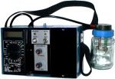
11. | *Device for process oil check for presence of emulsified water ПКТМ-641 – for check (detection) of water presence in oil – usage of change of phase at boiling up of emulsified water in oil heated in a special sensor at t = ~180 ^{о}С: amount of assay 33-35 ml, range of measurement of undissolved water content 0.01-99.99 microlitres. КД series is available in 2007 .
12. | Breakdown devices (installations) (test of solid dielectric products for electric strength of insulation with high voltage AC and assessment of escaping radiation current, easy for operation, compact, assembled on basis of high voltage Fart transformer models, U₁ = ~220V, 50 Hz):  - УП-641А (~ output voltage = to 10 kV, load current = 1 мА, 250х160х420 mm, ~11 kH); | 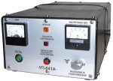
13. | - УП-641Б (~ output voltage = to 2.5 kV, load current = 1 мА, 250х160х400 mm, ~7.2 kH).
14. | Magnetic inductometer ИМИ-641 (determines the value and direction of the magnetic field, remnant magnetization: range 1 - 2000 mT, error 2.5%, digital, main piece – Hall device, universal power supply voltage - the same as in item 9) | 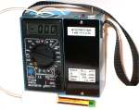
15. | Pressure meter (measures the value of contact pressure at the units of electrical machines, high voltage disconnectors and electrical equipment; >15 modifications /see the booklet/ of various thickness of the prod Н = from 2 to 110 mm, pressure force F = from 0.05 to 60/100 kgs – at smaller sizes the force range is more, more precise and efficient than all known analogues:  - ИН-641Б (power supply voltage +5V - 4 constituents of type А-316, size AA, LR6...; display unit is installed into the standard heat-resistant plastic frame G747 – 225х165х40mm, analogue ИН-641А, НИК-901…) | 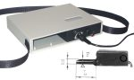
16. | - ИН-641В (power supply voltage – the same as in ИН-641Б, metal display unit –184х170х36mm) | 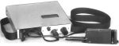
17. | - ИН-641Г (the same as ИН-641В but instead of removable batteries it features the universal power supply voltage: power circuit ~220V, 50/60Hz with the adapter and/or self-contained power supply of +5V - installed storage batteries charged from the adapter). Most popular (see the brochure): modification 01 – measurement of pressure of electric brushes on the collector in electric devices and modification 05 – for automatic devices of electric circuits and stations. | 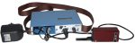
18. | - ИН-641Д (this meter includes functions of 10 modifications/ from 4 to 12 /first models:  force measurement range F = 0.4 + 70/100 kgs with discreteness of 0.1 kgs; Н is adjusted from 6 to 110 mm /with a slide gauge, with nozzles; universal power supply voltage as in ИН-641Г) | 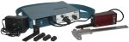
19. | - ИН-641Е (pressure meter for F control in pin jacks of high voltage gears of the “tulip” type, three modifications: for ø = 24 mm, 36mm or 55mm; universal power supply voltage as in ИН-641Г) | 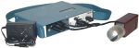
20. | Thread tension meter ИН-642 (measures tension of wire, chemical fiber, cord, waxed thread, firm yarn/thread/not stretched or stretched with the diameter of to 2mm, tension force F = 0.2 – 10.0 ±0.01 kgs) | 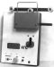
21. | Microhmmeter МОМ-641 (measures intermediate resistance of contact, terminal /bracing/ and other “cold” joints and connections, in units of metallization, ground connection; field resistance of electrical machines, transformers, four-terminal measurement circuit, digital, Rvariability = from 10 µOhm to 10 мOhm, universal power supply voltage - the same as in item 9) | 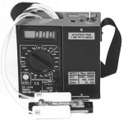  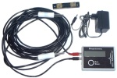
22. | Milliohm meter МОМ-642 - the same as in item 21 but Rvariability = from 10 mOhm to 20 Ohm  (in the multimeter mode milliohm meters measure the whole scale of resistance to 2 МОhm, i. е. it is possible to measure resistance from 10 µOhm to 2 МОhm included if both devices are available; portable)  МОМ-642А - the same as in item 23 but the length of measurement braids is 5 - 8 metres – by request.  (All milliohm meters are portable, in the multimeter mode they measure the whole scale of resistance to 2 МОhm)
23. | - *МОМ-643 (replaces MOM-641A) – performed by the microcontroller, Rvariability = from 10 µOhm to 10 mOhm, error not more than 2%, length of the measuring cord up to 10 meters, operation t = -20 to +50°C
24. | Electric power line (cable) tension meters (mounted, microprocessor) measure tension force F without breaking the circuit - line, cable, pole guys, girth rails, other cable connections (discreteness 0.001 ts, error not more than 1.5%, weight 2.5 – 5 kg, operation t = -20 to 50°C, power supply voltage - see item 17):  - ИН-642АM – force F from 0.02 to 2 ts;  ø cable 2 - 8 mm, spacing 0.33 m; | 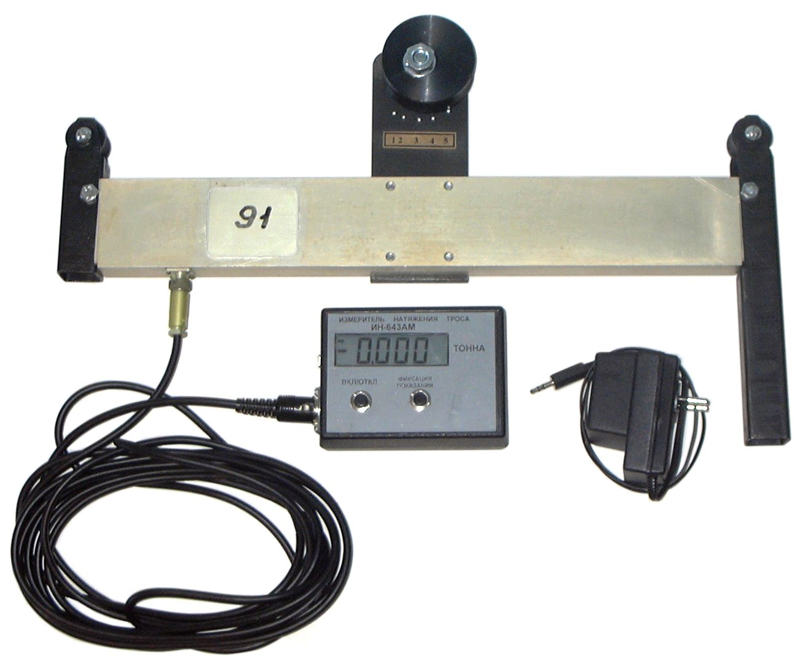  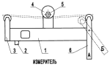
25. | - ИН-643M – force F from 0.03 to 3 ts; ø cable 5-15 mm, spacing 0.33 – 0.41 m;
26. | - ИН-643АM - force F from 0.05 to 5 ts; ø cable 10-20 mm, spacing 0.41 m;
27. | - ИН-643БM - force F from 0.1 to 10 ts; ø cable 15-25 mm, spacing 0.62 m;
28. | - ИН-643ВM - force F from 0.15 to 15 ts; ø cable 20-30 mm, spacing 0.96 m
29. | Meters for measuring tension of two cables … ИН-643ДM – mounted (plated) devices for simultaneous measuring tension force F of diametrically opposite pole guys without breaking the circuit (included: two mounted strain-gauge meters /two beams/ and an indication and measurement unit, four modifications for cables of ø as per items 24-25, 26, 27, 28; length of connection cables from measuring beams to the unit according to customer’s technical request). It is recommended to apply a goniometer when erecting supports, masts and antenna together with meters ИН-643 – see item 42. | 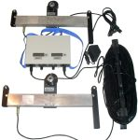
30. | Digital strain-gauge dynamometer ДТЦ-641 measures tension force to 10kgs with accuracy to 0.5%, discreteness 0.01kgs, convenient for measuring, e.g., pressure of electric brushes on the collector in large-size electric machines, compression or stretching of the spring (pin), rubber items – alternating (reversible), compact, efficient, universal power supply – see item 17.  *ДТЦ-642 – the same, but up to 20 kgs, accuracy 1%, discreteness 0.01kgs, metallic body | 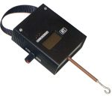
31. | Pressure meter ИН-644 for measuring pressure of electric brushes on the collector in the brush and contact unit of turbogenerators (e.g. ТВВ-500-2У3) during their work. Compact clip-on instruments register de-energization of the brush (circuit to 300А) at its stay (separation) from the collector and at this moment dynamometer takes readings of force F: range = 0.05 - 10 kgs; error < 0.05kgs. The meter can be applied to control of force in other large-size electric machines and high-voltage gears, if the construction permits and the item 31 is not enough. | 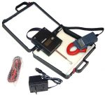
32. | Compound pressure meter ИН-645 (is destined for measuring force of contact pressure in electric brushes on the collector of large-size electric machines, it is equipped with two strain gauges: one from ИН-641… /modification 01 or 02 – by request/ - for measuring pressure under the electric brush or pressure pins /bottom/, the other from ИН-644 – for measuring pressure by drawing off the brush /pin, spring … - top/).
33. | *Pressure meter ИН-646 measures and indicates the value of contact pressure of trolleybus current collector, e.g., on the wire of the trolley line in the conditions of parking in the depot: force F from 2 to 20 kgs with accuracy to + 0.2 kgs, distance between the sensor and the measurement unit is to 10m. | 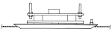  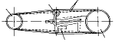
34. | *Belt strand tension gage ИН-647 (V-belt and flat belt) – control of equality of loads on the belt of sectional couples, screening and selection of identical ones with parameters: force F from 8 to 400 kgs, error to 2.5%; width of measured belts from 8 to 60 mm.  Production according to customer's requerements.
35. | Stroboscopic tachometer ТС-641 – non-contact digital probing of revolutions number per minute of the rotor of the electric motor or other rotating gears; it also registers vibration frequency of the controlled object: range 300 – 20000 rev/m or 10 – 330Hz with the error of to 3.5%; control distance - to 50 cm; portable; construction and design, size and weight, power supply voltage – see item 9. | 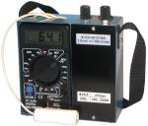
36. | Liquid injection device – for filling and pumping (to 18 l/m) of process liquids (e.g. in accumulator, electroplating shops) with different degree of viscosity (to 190 centistokes): acid, alkali, oil, drying oil, glue, resin, glycerin, solvents – from vessels:  - УНЖ-642Б - from glass bottles with the screw plug and capacity of 10, 20 litres; | 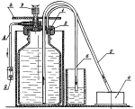
37. | - УНЖ-642Ф – from plastic cans with the screw plug and capacity of 40, 60 litres;
38. | Multipurpose portable liquid injection devices (immersion suction tube with the force connecting pipe, electric drive – pumping liquids from any vessel with the neck ø not less than 42 mm; power supply voltage=24-27 V /~220V/, 300-600 Wt, V=3500-5000 rev/m, to 200 centistokes, productiveness to 60 l/m):  -УПН-642А – for liquid pumping, including corrosive liquids, tubing - titanium, rigid vinyl plastic. | 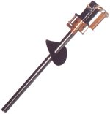
39. | -УПН-642Б – for pumping only neutral liquids (non-corrosive, non-explosive), tubing – stainless steel or steel with chemical cover (burnished).
40. | Electromagnetic presses (cold stamping on basis of pulse linear electromagnetic motor – compact presses) – successfully applied in the electrical and light industries (tag molding, production of printed circuit boards, mica, plastic, output of electronics, slotting, fixing of accessories on textiles and footwear, compacting of sand) - cutting, stamping, stretching, punching, riveting, coining, marking, bending, dressing, expansion, pressing in, forming /since the 2nd quarter of 2005 we have produced by request only unit-type spindle heads – pulse LEMM / :  - ПЭМ-641А (220 V, 250 Wt, force to 300 kgs, slide-block travel 35 mm, frequency to 400 stroke/m, mass ~ 30 kg, 280х320х440 mm); | 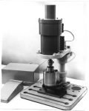  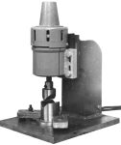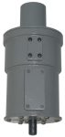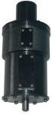
41. | - ПЭМ-641Б (220 V, 400 Wt, force to 700 kgs, , slide-block travel 35 mm, frequency to 200 stroke/m, mass ~ 35 kg, 280х320х460 mm);
42. | - ПЭМ-641В (220V, 700Wt, force to 1000kgs)
43. | *Digital goniometer УЦ-642 – besides accurate measurement and digital indication of the level, angle deviations, flatness and squareness, the main function of the item is to measure angles of dip of elements of power transmission lines (body of support, cross-beams, girth rails). It is recommended to apply when installing cell phone and radio and television towers, masts, aerials together with meters for measuring tension of cables ИН-643. It is performed on basis of PIC controller: range of measurement 360 = (4x90°C), error 0.05 to 0.1°; operation t=-40 to +60°C, 400x50x40mm, ~0.4 kg. Analogue of PRO 3600 (Mitutoyo, Japan). | 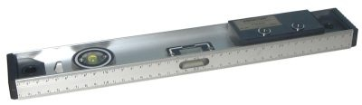
44. | *Detector – System meter ОИС-641 - measures digitally and ice-crusted ground layers and wind loads, force applied to phase cables and the thunder cable of the intermediate section of the power transmission lines, as well as ambient temperature. Range of measurement: ice-crusted ground load 20 to 600 kg, wind load with speed 2 to 40 m/s, t=-40 to +60°C. The set includes 3-5 sensors placed on the elements of the support and a portable block for information processing and indication.  Production according to customer's requerements.
45. | *Ice-crusted layer meter ИГО-641 measures only ice-crusted layers of ground and other loads exceeding tension force and weight of the thunder cable (or phase cable) up to the critical mass ~600 kgs, min set for one section of power transmission line is one sensor (see item 47), cable, connection outlet and block for information processing and indication. | 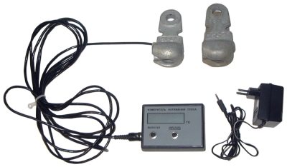
46. | *Strain-gauge transducer УДТ-641 – strain gauge and communication interaface with the block for information processing and indication are installed on the typical linear reinforcement of the power transmission line (suspensions of isolators – rings, one and two-part ears).
47. | Sources of supply and charging (units, adapters, storage battery) of 12 V - from 0.35 to 2 А. If the power circuit of 220V is available or not they can serve for supply and charging of devices –see items 7, 9, 10, 13 - 34 . | 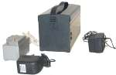
48. | Cases for packing, storage, transportation, serviceability of devices – plastic boxes (with a lock and handle) for ПМ, МОМ, ИН… produced and implemented earlier. Since 2004 products per items 7, 9, 10, 14 - 35, 44 have been packed in these cases (together). Two sizes: 160(200)х220х70 mm and 200(240)х230х80 mm. | 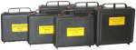
49. | Smolder detector УОТ-641 (registers initial stages of ignition at the controlled object: smouldering, arcing, smoking- infrared spectrum) | 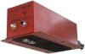
*New!
All products excluded from our catalogue remain on our web-site.

Post Office Box 1002, Saratov 410071, Russia
CJSC SPE "AVIASTEK"
Phone: +7 (845-2) 562501, 563809, 562503, 791201
Facsimile: +7 (845-2) 562501
E-mail: npp@aviastek.ru, aviastek@list.ru
Web-site: http://www.aviastek.ru

